# **Search in a Binary Search Tree**

You are given the root of a binary search tree (BST) and an integer val.

Find the node in the BST that the node's value equals val and return the subtree rooted with that node. If such a node does not exist, return null.

**Example 1:**

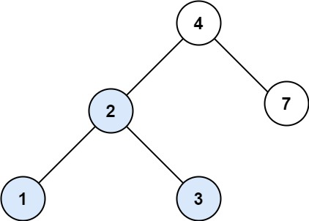

**Input:** root = [4,2,7,1,3], val = 2

**Output:** [2,1,3]

**Example 2:**

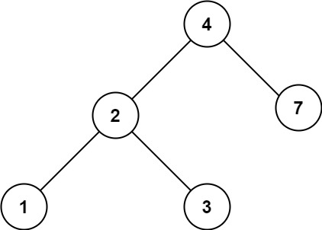

**Input:** root = [4,2,7,1,3], val = 5

**Output:** []

**Constraints:**

* The number of nodes in the tree is in the range [1, 5000].
* 1 <= Node.val <= 107
* root is a binary search tree.
* 1 <= val <= 107

/**

* Definition for a binary tree node.

* public class TreeNode {

* public int val;

* public TreeNode left;

* public TreeNode right;

* public TreeNode(int val=0, TreeNode left=null, TreeNode right=null) {

* this.val = val;

* this.left = left;

* this.right = right;

* }

* }

*/

public class Solution {

public TreeNode SearchBST(TreeNode root, int val) {

return Traverse(root,val);

}

TreeNode Traverse(TreeNode root, int val)

{

if(root == null)

{

return null;

}

if(root.val == val)

{

return root;

}

TreeNode l = Traverse(root.left, val);

if( l == null)

{

return Traverse(root.right, val);

}

else

{

return l;

}

}

}